2024 TAYC Annual - Summary
Chris and Campbell Conway sailed to a decisive victory in the 9 boat fleet at the TAYC Annual Regatta, sailed August 10th and 11th. With Jonathan Bartlett racing in Newport, and Bill Lawson returning from the Thistle Nationals in New Jersey, the door was open and the Conways, after a shaky start in a shortened race 1, went on to take bullets in 3 of the remaining six races. Bill loaned in boat to former Rolex Sailor of the year, and former Penguin sailor, Susan Taylor, who sailed to a second-place finish with Colette Preis as crew. Charlie Krafft with Donna McKenzie ended up losing the tie-breaker to take 3rd, followed closely by Patrick Brooks sailing with his son Bennett in Bennett's first regatta. Bob and Nora Tan were 5th, including a win in race 7; an extreme light-air drifter. Sandy McAllister, sailing with Annie Bartlett took sixth, including a bullet in race 1. Five different boats won races, showing the depth of competition in the fleet. Debbie and Ed Gosselin borrowed Jonathan's boat in their first Penguin regatta. After figuring out Sunday morning that Jonathan had left the bailers down, not up, the boat was a bit drier. I guess they don't have Andersen (Elvstrom) bailer on big boats. Mike Baugh, sailing with his son Rodric were the top (and unfortunately only) Classic Penguin, and were awarded the William and Alice Lane Classic Penguin perpetual trophy. Will Sheils sailing with his son Dixon borrowed Mike's modern boat, as they did last year, to round out the fleet. We hope to see them back in the Penguin, hopefully with a little better breeze. PRO and former Penguin sailor Eric Crawford did the best he could with the wind conditions. With only 6 full-rig Lasers (ILCA 7's) on the course and the Log Canoes confined to the river, we had reasonably good water conditions. We just needed a bit more wind.
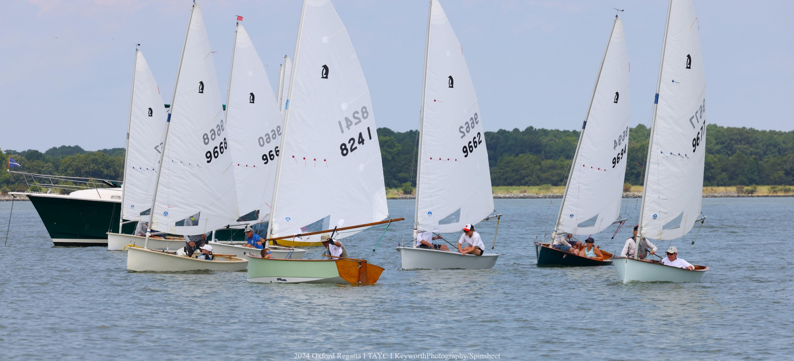
Off to the races – Mike Baugh (8241) trying a port tack start. Photo by Will Keyworth

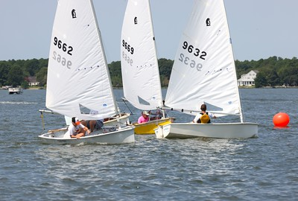
Patrick and Bennett Brooks leading at the windward mark. Photo by Will Keyworth.
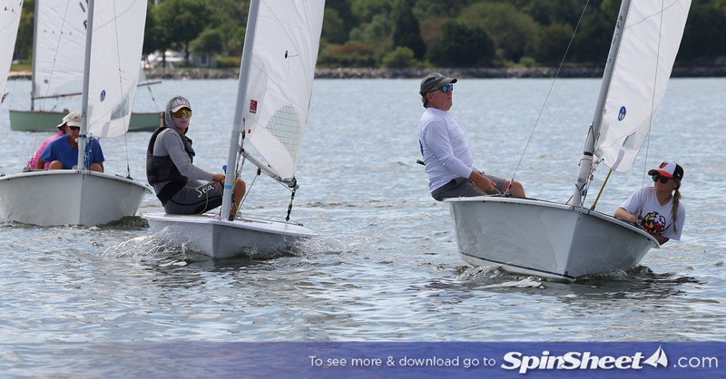
Sandy McAllister with Annie Bartlett, holding off an ILCA on the layline to the windward mark. Photo by Will Keyworth.
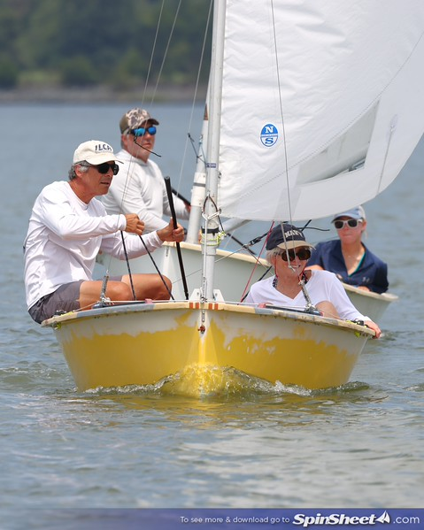
Bob and Nora Tan, ahead of Chris and Campbell Conway. Photo by Will Keyworth.
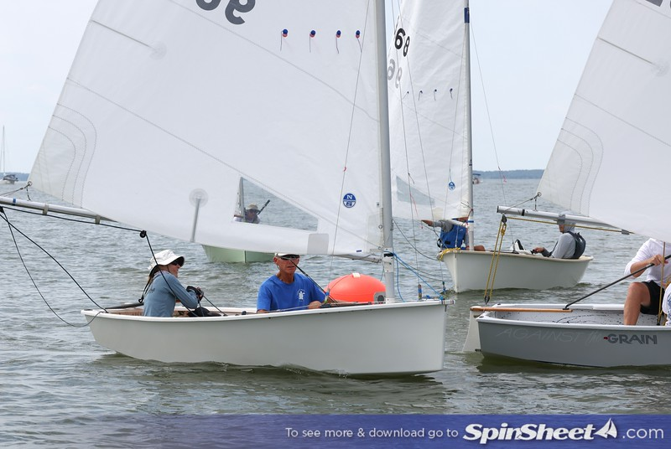
Debbie and Ed Gosselin – trying to figure this Penguin thing out. Photo by Will Keyworth.
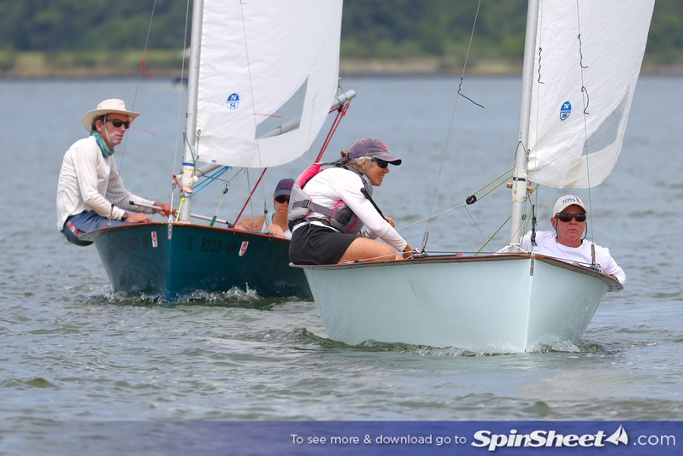
Susan Taylor with Colette Preis ahead of Charlie Krafft with Donna McKenzie. Photo by Will Keyworth

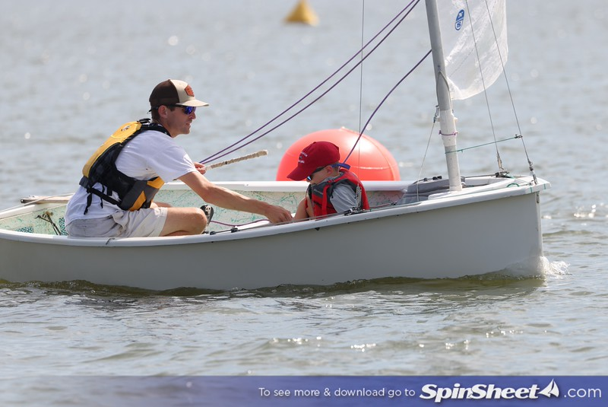
Patrick and Bennett Brooks – Bennett’s first regatta. Photo by Will Keyworth.
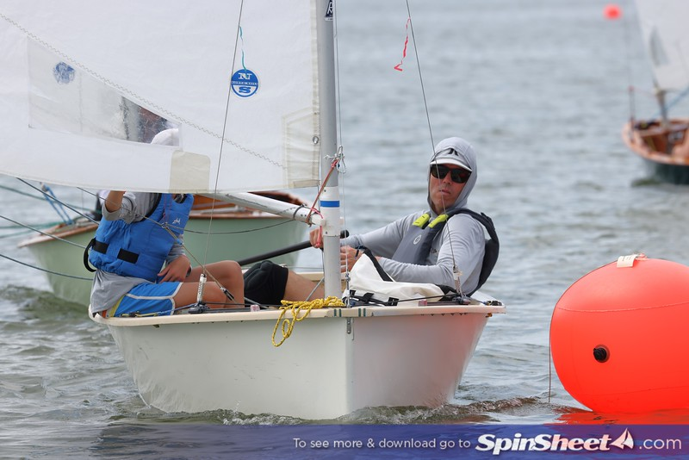
Wil and Dixon Shiels borrowed Mike Baugh’s boat, and are just ahead of him at the mark. Photo by Will Keyworth.

More photos available at: https://spinsheet.smugmug.com/SpinSheet/2024-Events

Results are posted at 2024 Oxford Regatta - Penguin & Adult ILCA 6/7 (theclubspot.com)

Sailors | Sail Number | Boat Name | Club/Org | Net | Total | R1 | R2 | R3 | R4 | R5 | R6 | R7
1 | Chris Conway  Campbell Conway | USA 9657 | C-Biscuit | AYC | 10 | 16 | [6] | 1 | 1 | 3 | 1 | 2 | 2
2 | Susan Taylor  Colette Preis | USA 9677 | Family Ties | SSA | 18 | 23 | [5] | 5 | 2 | 1 | 3 | 4 | 3
3 | Charles Krafft  Donna McKenzie | USA 9694 | Otter. B | SSA | 18 | 23 | 2 | 4 | 3 | 2 | 2 | [5] | 5
4 | Patrick Brooks  Bennett Brooks | USA 9632 | SPAX | TAYC | 19 | 25 | 3 | 3 | [6] | 4 | 4 | 1 | 4
5 | Bob Tan  Nora Beck Tan | USA 9669 | Ugly Duckling | Severn Sailing Association | 21 | 28 | [7] | 2 | 4 | 5 | 6 | 3 | 1
6 | William "Sandy" McAllister  Annie Bartlett | USA 9662 | Against The Grain | TAYC | 32 | 40 | 1 | 6 | 5 | 7 | [8] | 7 | 6
7 | Debbie Gosselin  Ed Gosselin | USA 9660 | Sister Mary Stigmata | AYC | 38 | 46 | [8] | 7 | 7 | 6 | 5 | 6 | 7
8 | Michael Baugh  Rodric Baugh | USA 8241 | Humble Pie | Tred Avon Yacht Club | 45 | 55 | 4 | 8 | 9 | 9 | 7 | 8 | [DNF - 10]
9 | Will Sheils  Dixon Sheils | USA 9668 | Lumpy | WRSC/AYC | 53 | 63 | 9 | 9 | 8 | 8 | 9 | [DNF - 10] | DNS - 10

